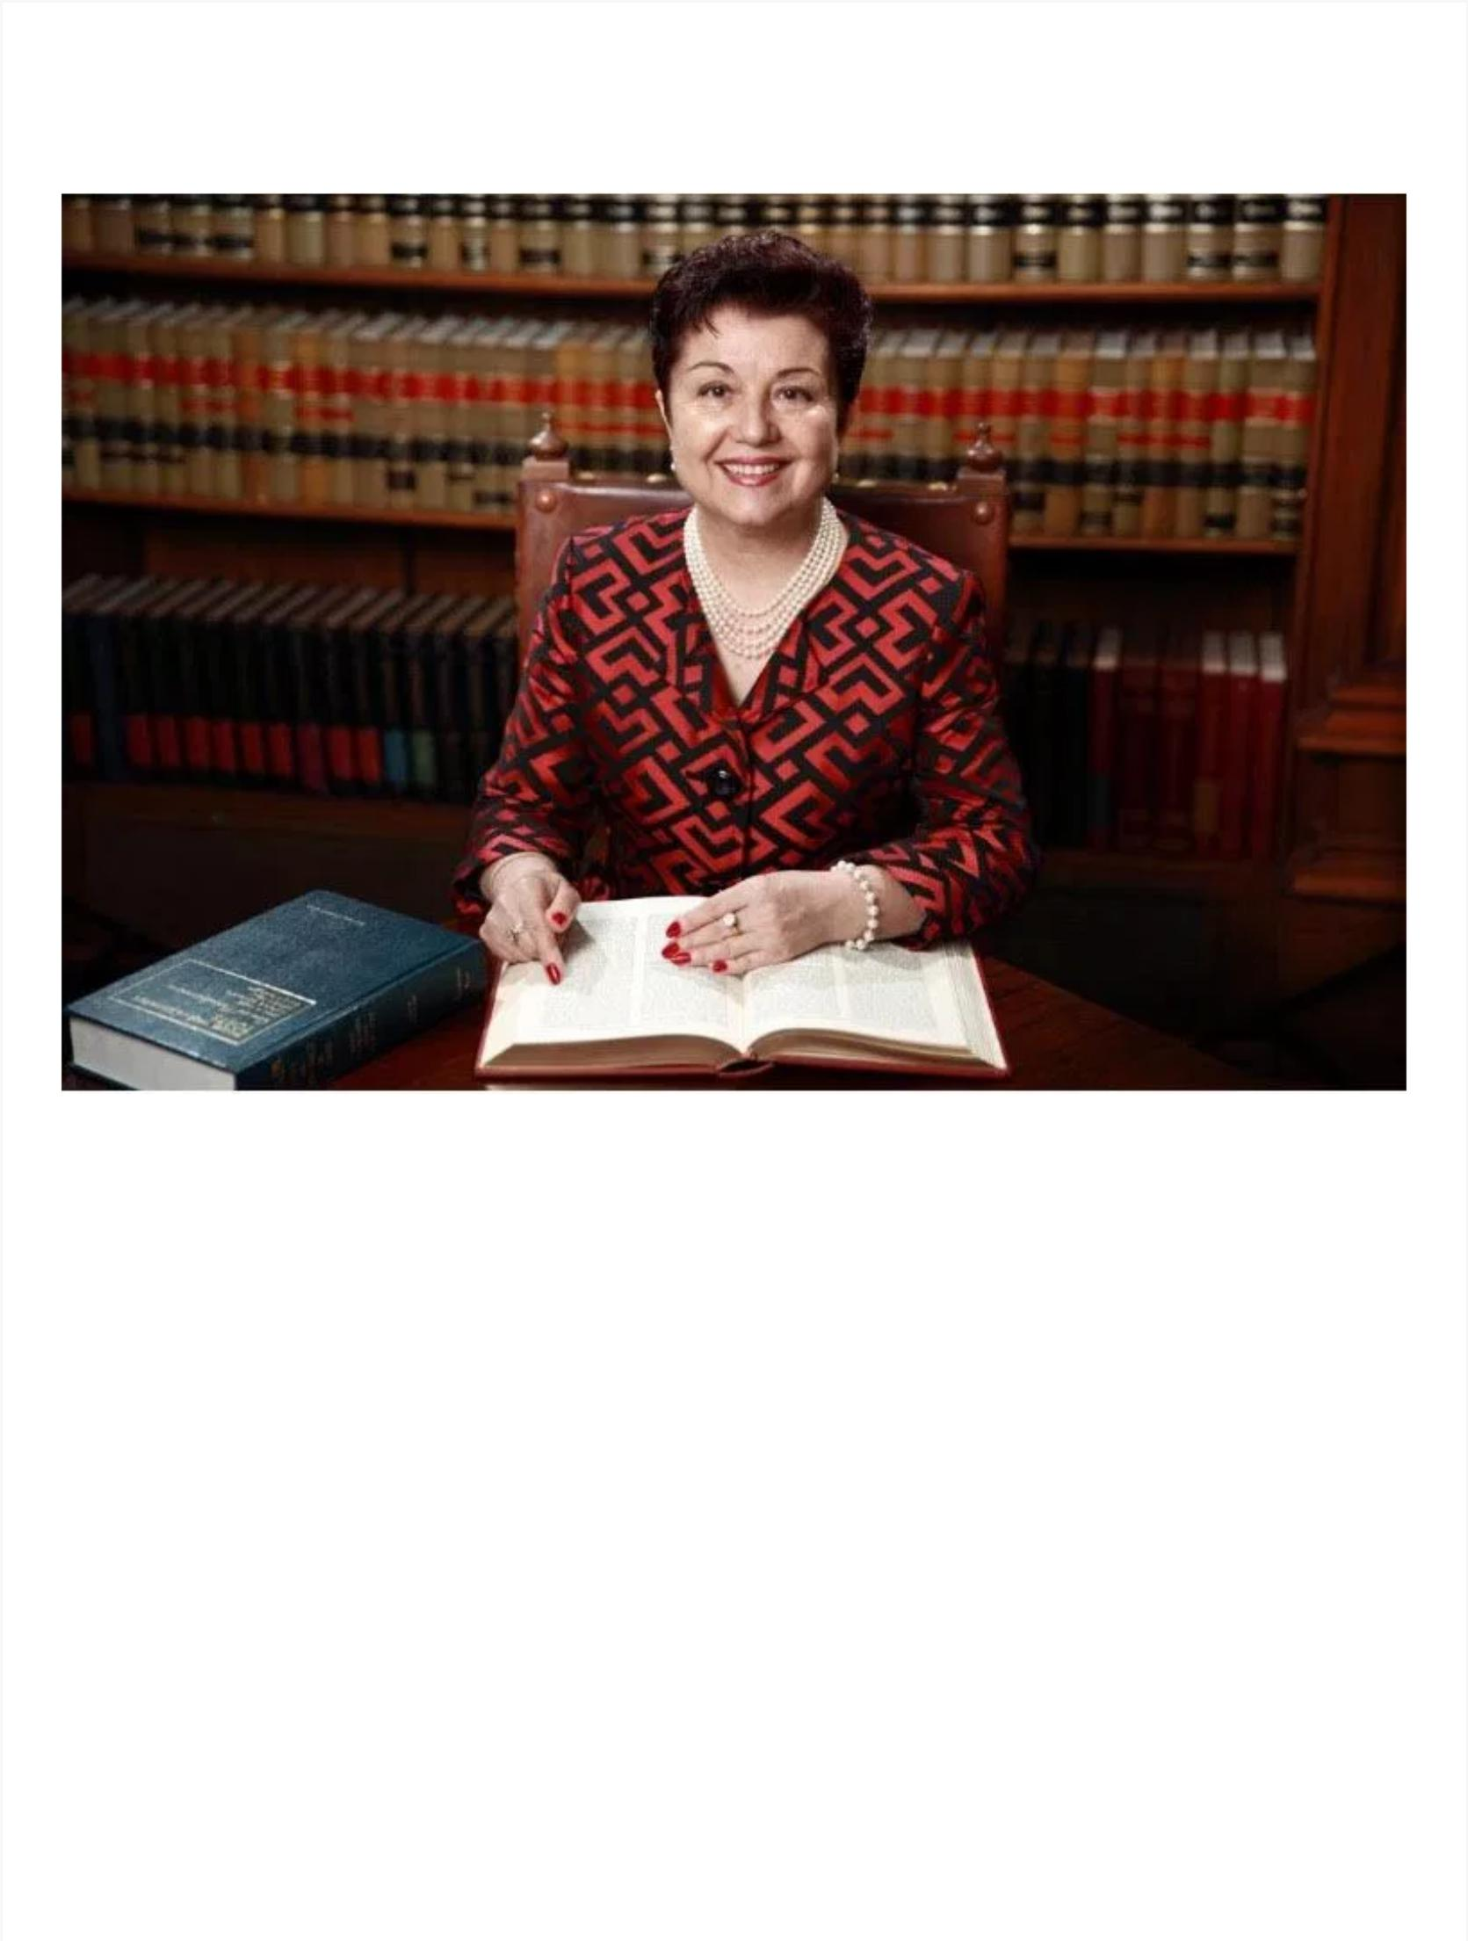
ABOUT VIRGINIA

Virginia Prodan is – an International Human Rights Attorney – an Allied Attorney with the Alliance Defending Freedom; a sought-after International Speaker – and an Author at Tyndale – President – Virginia Prodan Ministries – www.virginiaprodan.com .

Virginia had literally faced her assassin and has lived to tell about it. You will be inspired by her confidence and courage in the Lord and by her desire to share God’s love with anyone. She had shared it with the man who was hired to kill her. She is passionate about speaking and mentoring others who want to stand up to their giants and create a courageous, purpose-filled, and abundant life.

As a young attorney under Nicolae Ceausescu’s brutal communist regime, Virginia had spent her entire life searching for the truth. When she finally found it in the pages of the most forbidden book in all of Romania, Virginia accepted the divine call to defend fellow followers of Christ against unjust persecution in an otherwise ungodly land.

For this act of treason, she was kidnapped, beaten, tortured, placed under house arrest, and came within seconds of being executed under the orders of Ceausescu himself. How Virginia not only managed to defeat her enemies time and again, but helped expose the appalling secret that would lead to the demise of Ceausescu’s evil empire is one of the most extraordinary stories ever told.

Virginia Prodan’s compelling story of courage in the face of intimidation and even death on behalf of others is a testament to her unwavering faith in a God who delivers.

Exiled from Romania since 1988, Virginia frequently shares her story as the keynote speaker in large public forums—including public and private schools and universities—and has been featured prominently in media reports.

She was the focus of a full-length documentary and has been interviewed by Fox News, Heritage Foundation, BBC Radio, CBN, LifeWay – Chat with Priscilla, The NITE line, The Daily Signal, WFAA-TV Channel 8, Dallas Morning News, Point of View, Heritage Action for America, Glenn Beck, KCBI 90.9, Point of View, and Family Life – Dr. Jim Dobson.

Virginia is a sought-a er international speaker. As the key note speaker, Virginia spoke to large audiences and on special events at Family Research Council, Washington, DC; Christian Legal Fellowship, Vancouver, Canada; Summit Ministries, Colorado Springs; Georgetown University, etc. Virginia also published articles in Christian Post; the Christian Science Monitor; Focus on the Family – Citizen Magazine; Christianity Today; The Daily Signal; American Thinker, etc. Virginia inspires!

Virginia currently resides in Dallas, TX, where she enjoys practicing law, writing, attending the opera and the symphony, and traveling for pleasure. She has two daughters, Anca and Andreea, and a son, Emanuel. She also enjoys her numerous speaking engagements, where she continues to inspire and impact lives with her incredible true-life story.

Visit her at VirginiaProdanBooks.com,

COPYRIGHT © 2018 · VIRGINIA PRODAN

